**Однотабличные запросы**

-------------1------------

SELECT name, surname

FROM student

WHERE score BETWEEN 4 AND 4.5

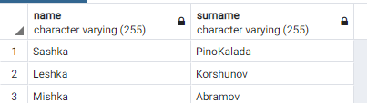

SELECT name, surname

FROM student

WHERE score>=4 and score<=4.5

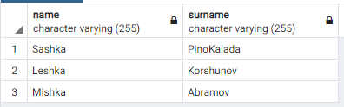

--------------2--------------

SELECT *

FROM student

WHERE CAST (student.n_group as varchar) like '2%';

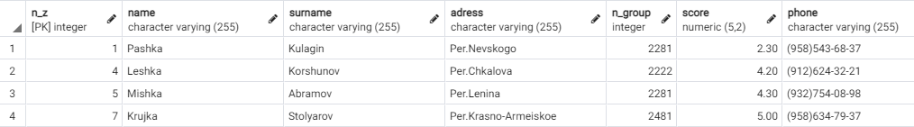

-------------3---------------

SELECT *

FROM student

Order by student.n_group DESC, student.name;

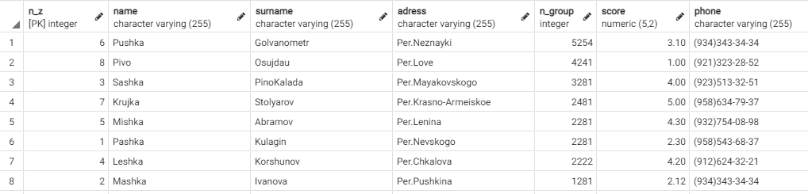

-------------4----------------

SELECT *

FROM student

WHERE score>4

Order by student.score DESC;

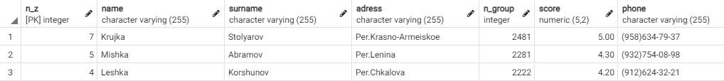

-------------5----------------

SELECT *

FROM student

WHERE score>4

Order by student.score DESC;

-------------6----------------

-------------7----------------

SELECT *

FROM student

WHERE score>4.5

ORDER BY score DESC;



-----------------8--------------

SELECT *

FROM student

WHERE score>4.5

ORDER BY score DESC

LIMIT 5;

-------------------9---------------

SELECT hobby_name,

CASE

WHEN risk>=8 THEN 'очень высокий'

WHEN risk<8 and risk>=6 THEN 'высокий'

WHEN risk<6 and risk>=4 THEN 'средний'

WHEN risk<4 and risk>=2 THEN 'низкий'

WHEN risk<2 THEN 'очень низкий'

END

FROM hobby;

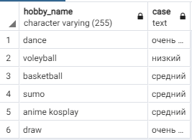

-------------------10---------------

SELECT *

FROM hobby

ORDER BY risk DESC LIMIT 3;

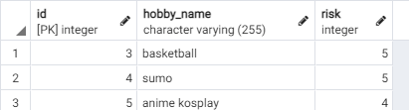

**Групповые функции**

--------------------------1---------------

SELECT n_group, COUNT (n_group)

FROM student

GROUP BY n_group

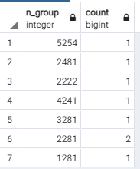

---------------------2-----------

SELECT n_group, AVG(score)

FROM student

GROUP BY n_group

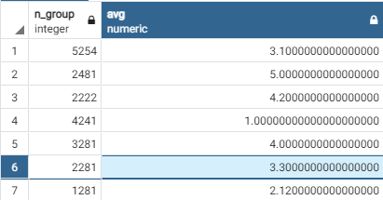

-----------3-----------------

SELECT surname, (COUNT (surname))

FROM student

GROUP BY surname

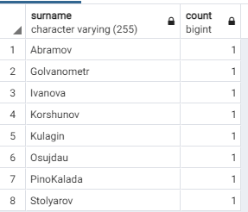

-----------------------4----------------

SELECT 2022-age as year, (COUNT (age))

FROM student

GROUP BY age

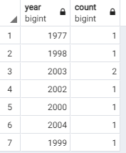

-----------------5-------------

SELECT n_group/1000 as course, (AVG (score))

FROM student

GROUP BY n_group/1000

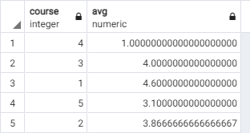

----------------6---------------

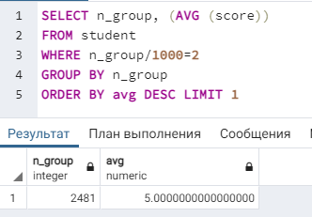

-----------------7---------------

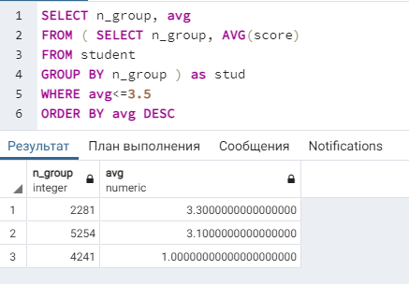

------------9---------------

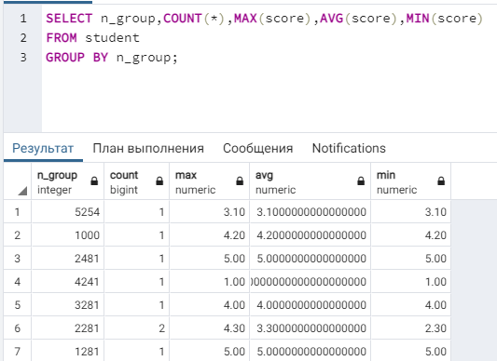

-----------------9-------------

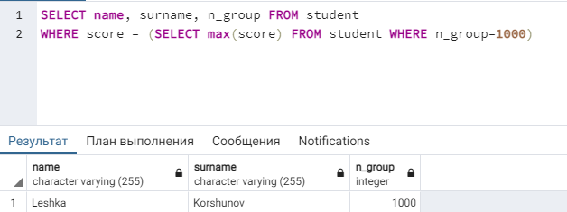

-----------------10---------------